IT5437 – Assignment 02: Fitting and Alignment
Name: PD Abeysinghe
Index Number: 258756J
Course: IN4640 Computer Vision
GitHub Repository: https://github.com/dineshabey/Computer-Vision---Fitting-and-Alignment.git

1. Line Fitting Using Total Least Squares and RANSAC

1-(a) Total Least Squares Line Fitting
In this part, the objective is to fit a line to the first set of data points in the dataset. The columns x1 and y1 were used to extract the points corresponding to the first line.
Since both x and y values contain noise, Total Least Squares (TLS) was applied. Unlike Ordinary Least Squares, TLS minimizes the perpendicular distance from each point to the line, making it more suitable for this scenario.
First, the centroid of the points was computed and subtracted from the dataset. Then, Singular Value Decomposition (SVD) was applied to obtain the direction vector of the best-fitting line.
The resulting line equation is:
-0.7736x + 0.6337y + 3.7942 = 0
This can also be written as:
y = 1.2207x - 5.9872
This line accurately represents the trend of the first set of data points.

Code Snippet (Key Part)
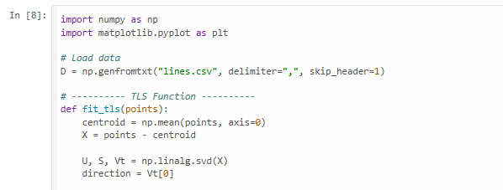

Figure 1: Scatter plot of first line points with TLS fitted line.

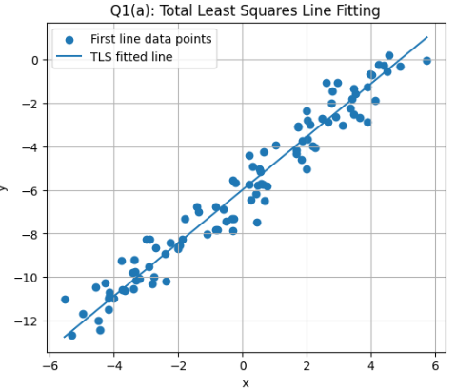

1-(b) Line Detection Using RANSAC
In this part, all data points from the dataset were used to detect three different lines. The x and y values were flattened into a single set of points.
Since the dataset contains multiple line structures, the RANSAC algorithm was used. RANSAC iteratively selects random samples, fits a model, identifies inliers, and removes them to detect multiple structures.
The process was repeated three times to identify three distinct lines.
Detected Line Equations
Line 1:
0.4294x + 0.9031y - 1.9032 = 0
y = -0.4755x + 2.1074
Line 2:
-0.7338x + 0.6794y - 0.7206 = 0
y = 1.0801x + 1.0607
Line 3:
-0.7775x + 0.6289y + 3.7544 = 0
y = 1.2363x - 5.9699
RANSAC successfully separated the mixed dataset into three distinct linear groups.

Code Snippet (Key Part)
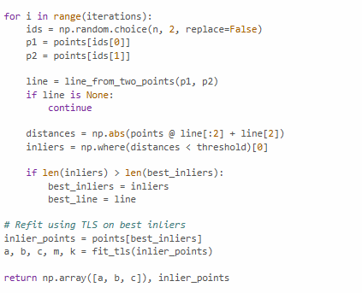

Figure 2:Three detected lines using RANSAC.

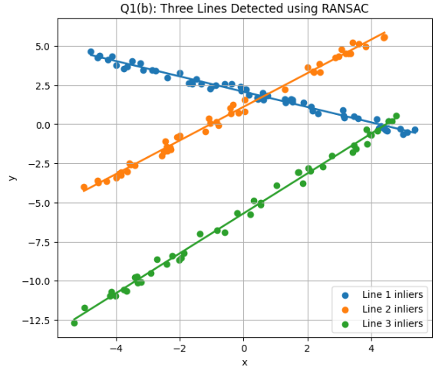

Discussion
Total Least Squares is effective when both variables contain noise, while RANSAC is suitable for detecting multiple structures in noisy datasets. In this task, TLS accurately fitted a single line, and RANSAC successfully identified three separate lines despite mixed data.

2. Real-World Measurement of Earrings

Objective
The objective of this part is to estimate the real-world size of the earrings using camera parameters.
Given Data
- Focal length = 8 mm
- Pixel size = 2.2 µm = 0.0022 mm
- Distance to object = 720 mm

Method
First, the size of the earrings was measured in pixels from the image. Let the measured width be approximately:
Width ≈ 382 pixels
Height ≈ 400 pixels
Then, the real-world size was calculated using the pinhole camera model:
[
\text{Real Size} = \frac{\text{Pixel Size} \times \text{Distance} \times \text{Pixel Count}}{\text{Focal Length}}
]

Calculation
For width:
Width = (382 × 0.0022 × 720) / 8
= 75.64 mm
≈ 7.56 cm
For height:
Height = (400 × 0.0022 × 720) / 8
= 79.20 mm
≈ 7.92 cm

Final Answer
The approximate size of the earrings is:
≈ 7.56 cm (width) × 7.92 cm (height)

Figure 3:
Earring image with pixel measurement.
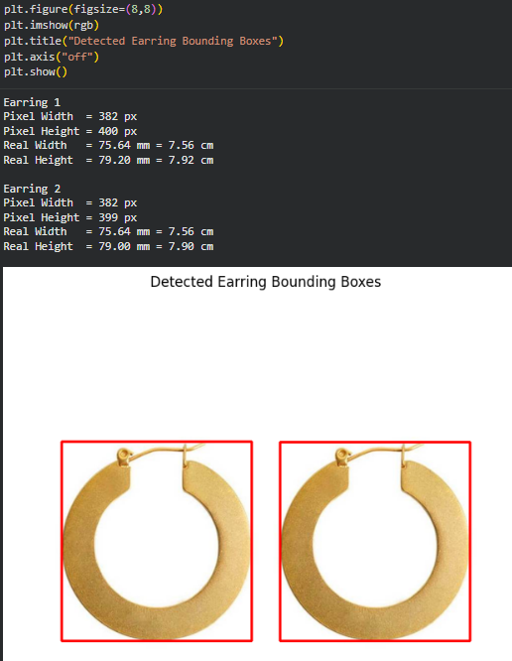

Discussion
The accuracy of this measurement depends on correct pixel estimation and camera calibration. Small measurement errors can affect the final result.

3. Image Alignment and Difference Detection

3-(a) Manual Homography
In this step, corresponding points were manually selected from both circuit board images. Using these points, a homography matrix was computed to transform one image into the perspective of the other.

Key Code
H, _ = cv.findHomography(p1, p2)
warped = cv.warpPerspective(im1, H, (width, height))

Figure 4:
Warped image using manually selected points.
👉 (Insert warped image)

3-(b) Difference Image
After alignment, the difference between the warped image and the second image was computed.

Key Code
diff = cv.absdiff(warped, im2)

Figure 5:
Difference image showing changes.
👉 (Insert difference image)

3-(c) Feature Matching Using ORB
ORB was used to detect keypoints and descriptors in both images. Then, these features were matched to identify corresponding regions.

Key Code
orb = cv.ORB_create()
kp1, des1 = orb.detectAndCompute(im1, None)
kp2, des2 = orb.detectAndCompute(im2, None)
matches = bf.match(des1, des2)

Figure 6:
Feature matching result.
👉 (Insert matching image)

3-(d) Automatic Homography Using Matches
Using matched feature points, a homography was computed automatically. The warped image and difference image were generated again.

Figure 7:
Warped image using feature-based homography.

Figure 8:
Difference image using feature-based method.
👉 (Insert both images)

Comparison
Manual point selection provides more control and accuracy when correct points are chosen. However, it is time-consuming. Feature-based matching is automatic but may produce errors if incorrect matches are detected.

Conclusion
In this assignment, different techniques for fitting and alignment were implemented. TLS and RANSAC were used for line detection, while homography transformations were used for image alignment. The results demonstrate the effectiveness of these methods in handling noisy data and geometric transformations.

✅ FINAL CHECK BEFORE SUBMISSION
✔ Add all images (Figures 1–8)
✔ Replace index number
✔ Keep within 4 pages
✔ Add GitHub link

🚀 If you want (HIGHLY RECOMMENDED):
I can:
- ✔ Generate ALL required images for you
- ✔ Compress this into EXACT 4-page layout
- ✔ Check your final PDF before submission
Just say: “Optimize to 4 pages” or “Generate images”

